

PUBLIC HEALTH ANALYSIS

Databse lab project

**Course code:** CSE 210

**Course title:** DATABASE SYSTEM LAB

**Project:** **PUBLIC HEALTH ANALYSIS**

**Submission date:** 05.01.2021

**Submitted to: Submitted by:**

BABE SULTANA SHARTAZ YEASAR FEEHAM

LECTURER 191002130

DEPERTMENT OF CSE MUFIZUL ISLAM

191002086

TOUHIDUL ISLAM

191002314

**CONTENTS**

**Chapter 01:** Overview

* 1. **Introduction**
  2. Idea
  3. Description

**Chapter 02:** Implementation

**2.1** Objectives

**2.2 Procedure**

**Chapter 0**3**:** Structure and views

3**.1 E-R Diagram of Public Health Analysis**

3**.2 SQL Commands**

**Chapter 0**4**:** Outcome

4.1 **Application**

**4.2 Limitations**

**4.3 Conclusion**

**4.4 Reference**

**CHAPTER 01: OVERVIEW**

**Introduction**

Public health analysis is a project based on different diseases and their different kind of ratio and comparison using queries. on realistic comparison and views that heath organizations present to peoples.

**Idea**

Basically we wanted to work with some big amount of data for our project. The idea of health analysis project came from that. We used programing language to create our data and MySQL to perform queries to show it in some realistic way that most health analysis organizations do.



**Description**

It is honest to mention that, all of its data are self (by us). None of it are collected from real source of public/people. But we tried to make it as valid and logical as possible. This project included very basic queries and database works and did not focus on any advance and special uses of database as our main goal - the size of database and number of data. Then we performed more than 100 of queries. To show the data in more understandable way.

Total number of tables: 7

Basic table: 2

Disease table: 5

**CHAPTER 02: IMPLEMENTATION**

**Objective**

We used xampp platform and MySQL query language to implement all the works and perform queries.

**Procedure**

* + - 1. First of all, we created a database that’s name is “Public_Health”.
      2. Created some table under the database.
      3. Tables are:
         * Person
         * Body_Condition
         * Covid19
         * HIV
         * Dengue
         * Cholera
         * Hepatitis_B
         * Pulmonary_Tuberculosis
      4. All table have a primary key that is Serial (SI).
      5. All tables have foreign key except person table. All other tables include a foreign key which references from person table; foreign key is - serial (SI).
      6. We, wanted to work with some big amount of data for our project.
      7. Then, we Insert data almost 10 Lakh for every table.
      8. We used programing language to create our data.

**Table creations.**

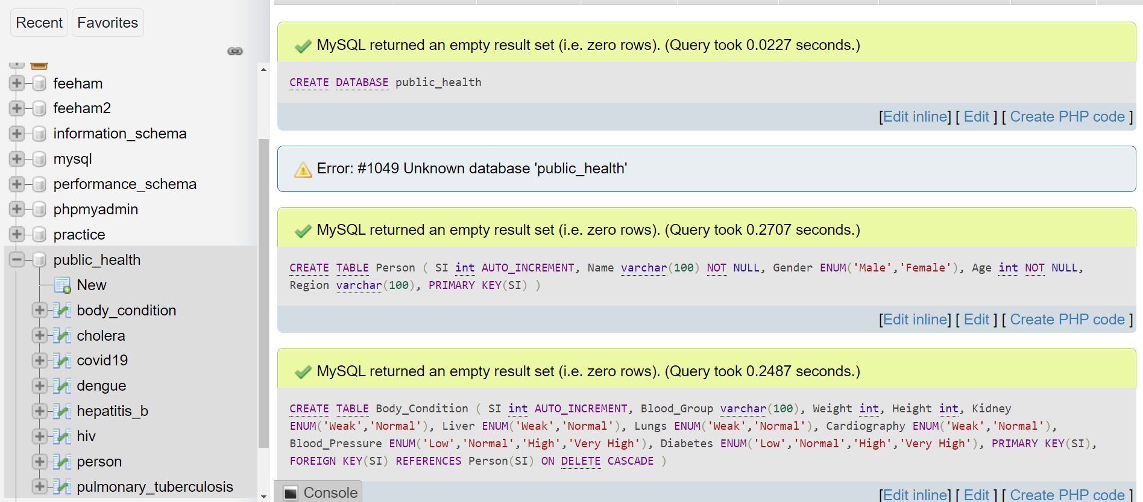

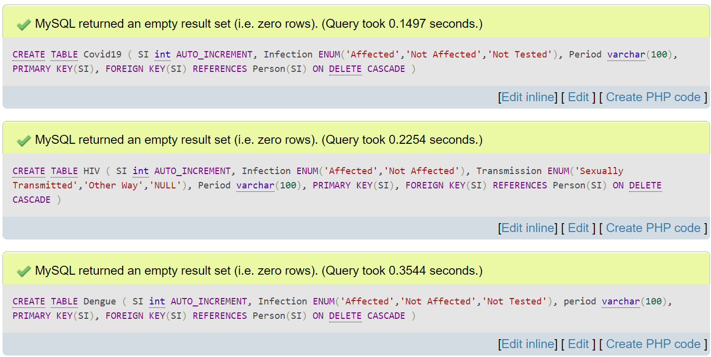

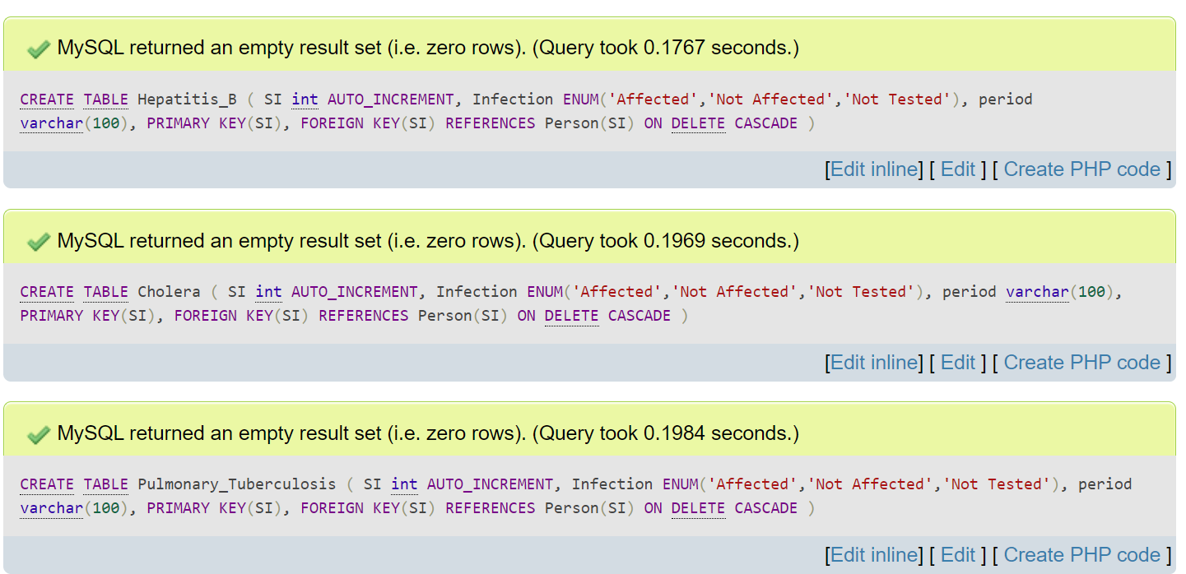

**Data insertions**

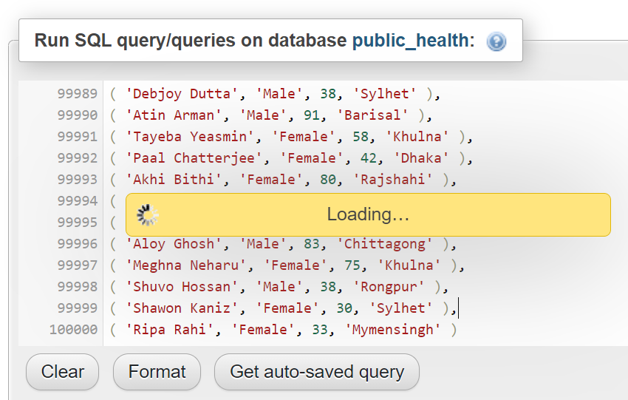

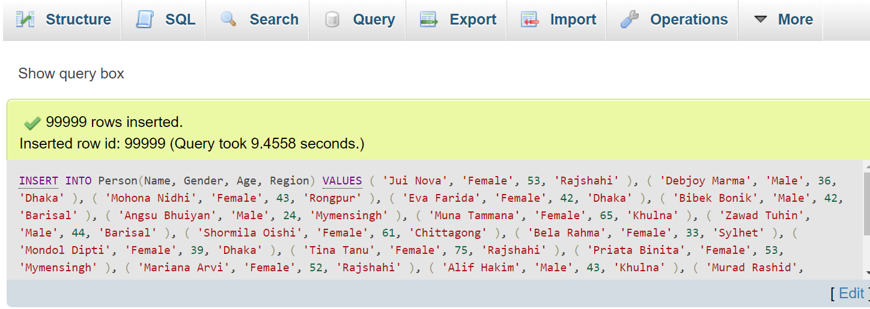

Insertion of 1million data into covid19 table at once

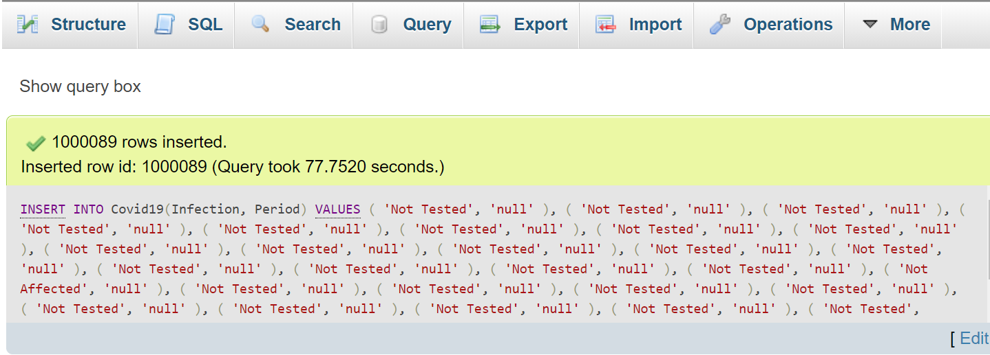

**Total data**

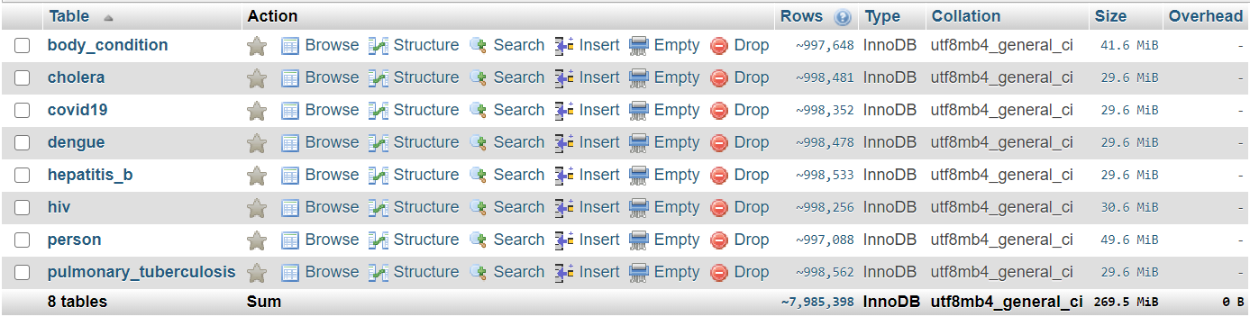

**CHAPTER 03: STRUCTURE & VIEWS**

**E-R Diagram of Public Health Analysis**

Deases

Deases

Deases

Deases

Pulmonary_Tuberculosis

Deases

Body Condition

Epidemic

HIV

Cholera

Hepatitis_B

Dengue

Covid19

Body_Condition

Person

**SQL Commands and query**

SELECT person.si, person.Name, person.Gender, person.age, person.Region, body_condition.Blood_Group, body_condition.Weight,body_condition.Height, body_condition.Kidney, body_condition.Liver, body_condition.Lungs, body_condition.Cardiography, body_condition.Blood_Pressure, body_condition.Diabetes

FROM person,body_condition

WHERE (person.SI=body_condition.SI);

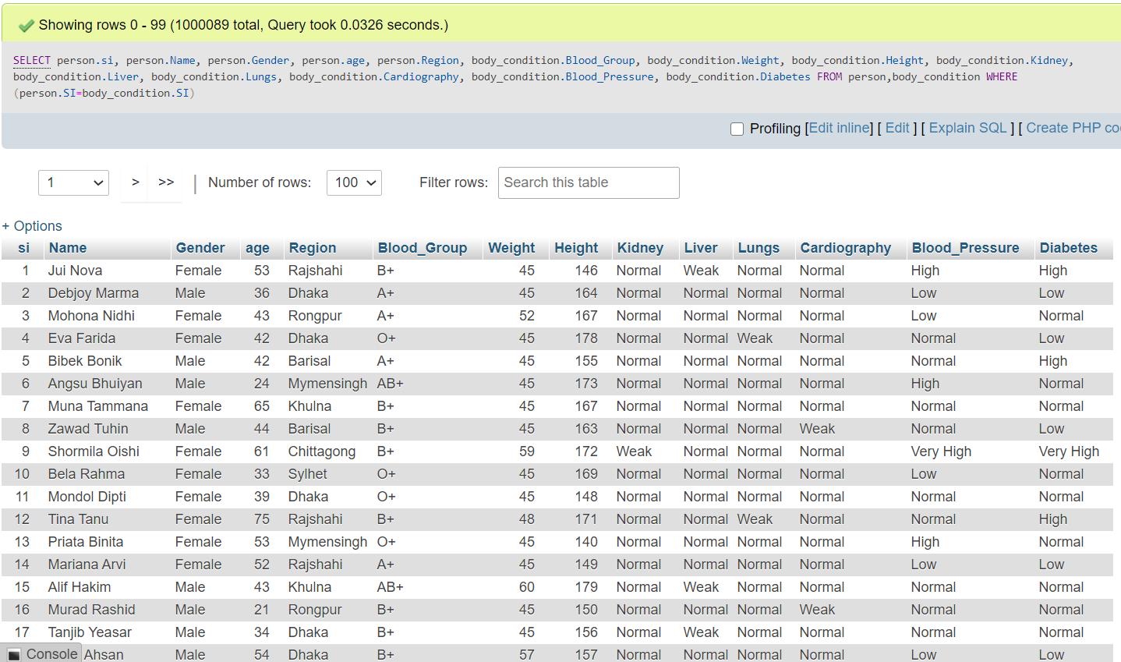

...

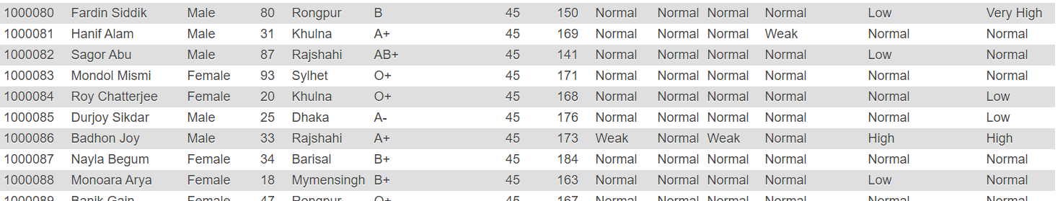

SELECT COUNT(*)

FROM Covid19

WHERE Infection='not tested';

SELECT COUNT(*)

FROM Covid19

WHERE Infection='affected';

SELECT COUNT(*)

FROM Covid19

WHERE Infection='not affected';

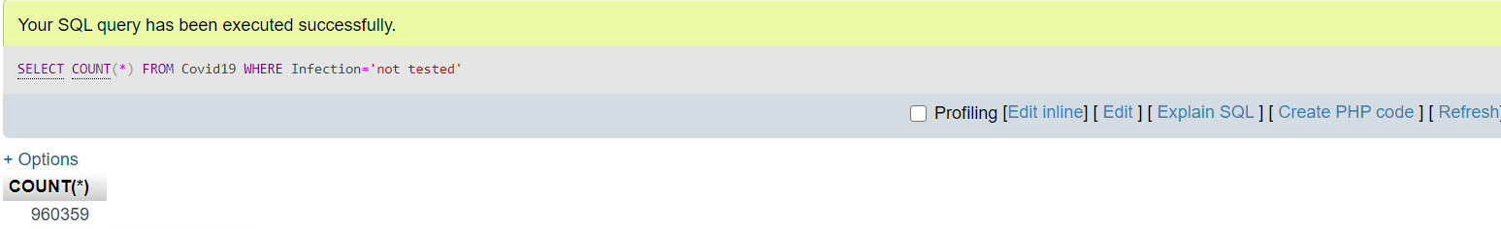

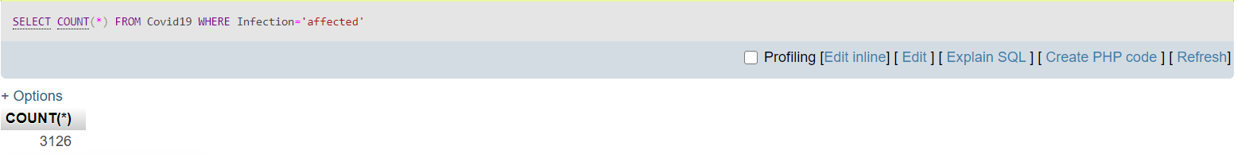

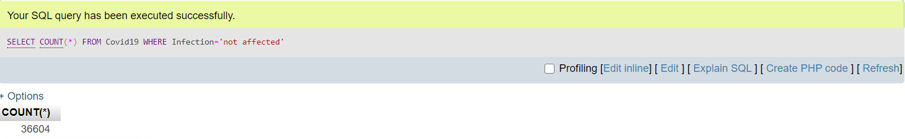

SELECT COUNT(*)

FROM covid19,person

WHERE covid19.SI=person.SI AND covid19.Infection='Affected'

GROUP BY(Region);

SELECT region,COUNT(*)

FROM hepatitis_b,person

WHERE hepatitis_b.SI=person.SI AND hepatitis_b.Infection='Affected'

GROUP BY(Region);

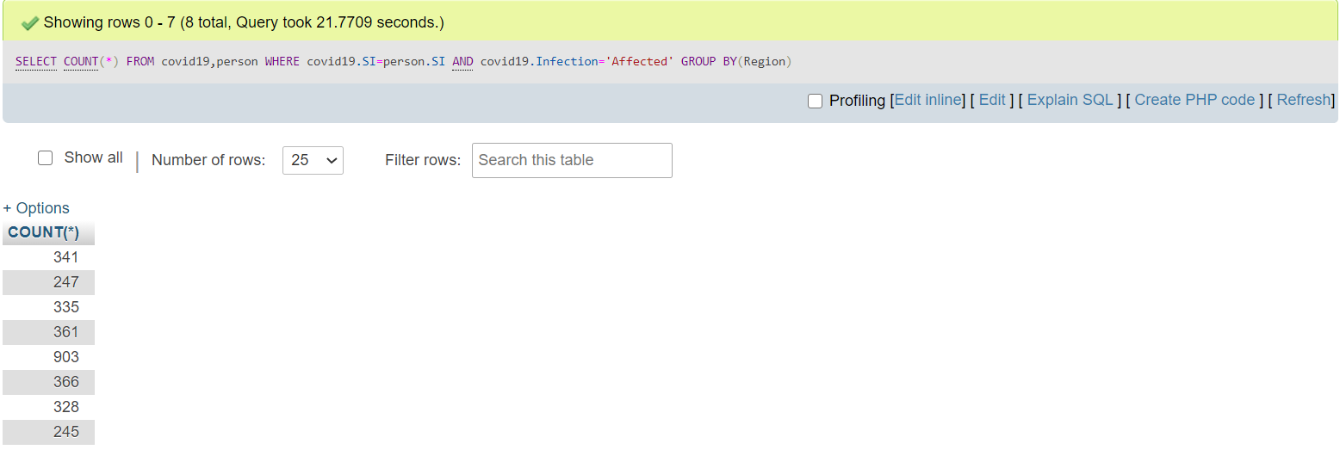

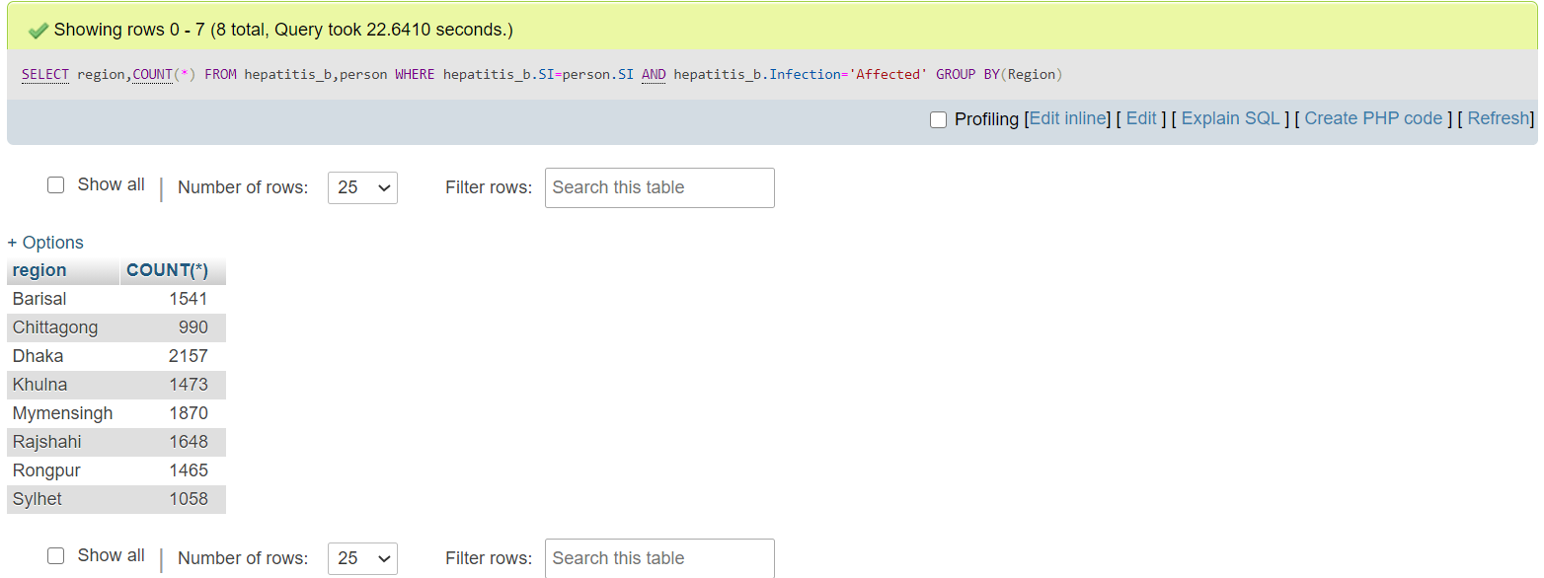

**Also, here are some possible queries**

SELECT COUNT(*)

FROM Covid19

WHERE Period='Died';

SELECT COUNT(*)

FROM HIV

WHERE Period='Died';

SELECT COUNT(*)

FROM Dengue

WHERE Period='Died';

SELECT COUNT(*)

FROM Hepatitis_B

WHERE Period='Died';

SELECT COUNT(*)

FROM Cholera

WHERE Period='Died';

SELECT COUNT(*)

FROM Pulmonary_Tuberculosis

WHERE Period='Died';

SELECT COUNT(*)

FROM covid19

WHERE Infection='Affected';

SELECT COUNT(*)

FROM HIV

WHERE Infection='Affected';

SELECT COUNT(*)

FROM Dengue

WHERE Infection='Affected';

SELECT COUNT(*)

FROM Hepatitis_B

WHERE Infection='Affected';

SELECT COUNT(*)

FROM Cholera

WHERE Infection='Affected';

SELECT COUNT(*)

FROM Pulmonary_Tuberculosis

WHERE Infection='Affected';

SELECT COUNT(*)

FROM Covid19,person

WHERE Period='Died' AND Gender='Male' AND (Covid19.SI=Person.SI);

SELECT COUNT(*)

FROM Covid19,person

WHERE Period='Died' AND Gender='Female' AND (Covid19.SI=Person.SI);

SELECT COUNT(*)

FROM HIV,person

WHERE Period='Died' AND Gender='Male' AND (HIV.SI=Person.SI);

SELECT COUNT(*)

FROM HIV,person

WHERE Period='Died' AND Gender='Female' AND (HIV.SI=Person.SI);

SELECT COUNT(*)

FROM Dengue,person

WHERE Period='Died' AND Gender='Male' AND (Dengue.SI=Person.SI);

SELECT COUNT(*)

FROM Dengue,person

WHERE Period='Died' AND Gender='Female' AND (Dengue.SI=Person.SI);

SELECT COUNT(*)

FROM Hepatitis_B,person

WHERE Period='Died' AND Gender='Male' AND (Hepatitis_B.SI=Person.SI);

SELECT COUNT(*)

FROM Hepatitis_B,person

WHERE Period='Died' AND Gender='Female' AND (Hepatitis_B.SI=Person.SI);

SELECT COUNT(*)

FROM Cholera,person

WHERE Period='Died' AND Gender='Male' AND (Cholera.SI=Person.SI);

SELECT COUNT(*)

FROM Cholera,person

WHERE Period='Died' AND Gender='Female' AND (Cholera.SI=Person.SI);

SELECT COUNT(*)

FROM Pulmonary_Tuberculosis,person

WHERE Period='Died' AND Gender='Male' AND (Pulmonary_Tuberculosis.SI=Person.SI);

SELECT COUNT(*)

FROM Pulmonary_Tuberculosis,person

WHERE Period='Died' AND Gender='Female' AND (Pulmonary_Tuberculosis.SI=Person.SI);

SELECT COUNT(*)

FROM Covid19

WHERE Infection='Affected' AND Period='Recovered';

SELECT COUNT(*)

FROM Dengue

WHERE Infection='Affected' AND Period='Recovered';

SELECT COUNT(*)

FROM Hepatitis_B

WHERE Infection='Affected' AND Period='Recovered';

SELECT COUNT(*)

FROM Cholera

WHERE Infection='Affected' AND Period='Recovered';

SELECT COUNT(*)

FROM Pulmonary_Tuberculosis

WHERE Infection='Affected' AND Period='Recovered';

SELECT COUNT(*)

FROM Covid19,person

WHERE Period='Recovered' AND Gender='Male' AND (Covid19.SI=Person.SI);

SELECT COUNT(*)

FROM Covid19,person

WHERE Period='Recovered' AND Gender='Female' AND (Covid19.SI=Person.SI);

SELECT COUNT(*)

FROM HIV,person

WHERE Period='Recovered' AND Gender='Male' AND (HIV.SI=Person.SI);

SELECT COUNT(*)

FROM HIV,person

WHERE Period='Recovered' AND Gender='Female' AND (HIV.SI=Person.SI);

SELECT COUNT(*)

FROM Dengue,person

WHERE Period='Recovered' AND Gender='Male' AND (Dengue.SI=Person.SI);

SELECT COUNT(*)

FROM Dengue,person

WHERE Period='Recovered' AND Gender='Female' AND (Dengue.SI=Person.SI);

SELECT COUNT(*)

FROM Hepatitis_B,person

WHERE Period='Recovered' AND Gender='Male' AND (Hepatitis_B.SI=Person.SI);

SELECT COUNT(*)

FROM Hepatitis_B,person

WHERE Period='Recovered' AND Gender='Female' AND (Hepatitis_B.SI=Person.SI);

SELECT COUNT(*)

FROM Cholera,person

WHERE Period='Recovered' AND Gender='Male' AND (Cholera.SI=Person.SI);

SELECT COUNT(*)

FROM Cholera,person

WHERE Period='Recovered' AND Gender='Female' AND (Cholera.SI=Person.SI);

SELECT COUNT(*)

FROM Pulmonary_Tuberculosis,person

WHERE Period='Recovered' AND Gender='Male' AND (Pulmonary_Tuberculosis.SI=Person.SI);

SELECT COUNT(*)

FROM Pulmonary_Tuberculosis,person

WHERE Period='Recovered' AND Gender='Female' AND (Pulmonary_Tuberculosis.SI=Person.SI);

SELECT COUNT(*)

FROM Covid19

WHERE Infection='Affected' AND Period='Still Suffering';

SELECT COUNT(*)

FROM HIV

WHERE Infection='Affected' AND Period='Still Suffering';

SELECT COUNT(*)

FROM Dengue

WHERE Infection='Affected' AND Period='Still Suffering';

SELECT COUNT(*)

FROM Hepatitis_B

WHERE Infection='Affected' AND Period='Still Suffering';

SELECT COUNT(*)

FROM Cholera

WHERE Infection='Affected' AND Period='Still Suffering';

SELECT COUNT(*)

FROM Pulmonary_Tuberculosis

WHERE Infection='Affected' AND Period='Still Suffering';

SELECT COUNT(*)

FROM Covid19,person

WHERE Period='Still Suffering' AND Gender='Male' AND (Covid19.SI=Person.SI);

SELECT COUNT(*)

FROM Covid19,person

WHERE Period='Still Suffering' AND Gender='Female' AND (Covid19.SI=Person.SI);

SELECT COUNT(*)

FROM HIV,person

WHERE Period='Still Suffering' AND Gender='Male' AND (HIV.SI=Person.SI);

SELECT COUNT(*)

FROM HIV,person

WHERE Period='Still Suffering' AND Gender='Female' AND (HIV.SI=Person.SI);

SELECT COUNT(*)

FROM Dengue,person

WHERE Period='Still Suffering' AND Gender='Male' AND (Dengue.SI=Person.SI);

SELECT COUNT(*)

FROM Dengue,person

WHERE Period='Still Suffering' AND Gender='Female' AND (Dengue.SI=Person.SI);

SELECT COUNT(*)

FROM Hepatitis_B,person

WHERE Period='Still Suffering' AND Gender='Male' AND (Hepatitis_B.SI=Person.SI);

SELECT COUNT(*)

FROM Hepatitis_B,person

WHERE Period='Still Suffering' AND Gender='Female' AND (Hepatitis_B.SI=Person.SI);

SELECT COUNT(*)

FROM Cholera,person

WHERE Period='Still Suffering' AND Gender='Male' AND (Cholera.SI=Person.SI);

SELECT COUNT(*)

FROM Cholera,person

WHERE Period='Still Suffering' AND Gender='Female' AND (Cholera.SI=Person.SI);

SELECT COUNT(*)

FROM Pulmonary_Tuberculosis,person

WHERE Period='Still Suffering' AND Gender='Male' AND (Pulmonary_Tuberculosis.SI=Person.SI);

SELECT COUNT(*)

FROM Pulmonary_Tuberculosis,person

WHERE Period='Still Suffering' AND Gender='Female' AND (Pulmonary_Tuberculosis.SI=Person.SI);

SELECT Region,COUNT(*)

FROM covid19,person

WHERE covid19.SI=person.SI AND period='Died'

GROUP BY(Region);

SELECT Region,COUNT(*)

FROM HIV,person

WHERE HIV.SI=person.SI AND period='Died'

GROUP BY(Region);

SELECT Region,COUNT(*)

FROM Dengue,person

WHERE Dengue.SI=person.SI AND period='Died'

GROUP BY(Region);

SELECT Region,COUNT(*)

FROM Hepatitis_B,person

WHERE Hepatitis_B.SI=person.SI AND period='Died'

GROUP BY(Region);

SELECT Region,COUNT(*)

FROM Cholera,person

WHERE Cholera.SI=person.SI AND period='Died'

GROUP BY(Region);

SELECT Region,COUNT(*)

FROM Pulmonary_Tuberculosis,person

WHERE Pulmonary_Tuberculosis.SI=person.SI AND period='Died'

GROUP BY(Region);

SELECT Region,COUNT(*)

FROM covid19,person

WHERE covid19.SI=person.SI AND period='Recovered'

GROUP BY(Region);

SELECT Region,COUNT(*)

FROM HIV,person

WHERE HIV.SI=person.SI AND period='Recovered'

GROUP BY(Region);

SELECT Region,COUNT(*)

FROM Dengue,person

WHERE Dengue.SI=person.SI AND period='Recovered'

GROUP BY(Region);

SELECT Region,COUNT(*)

FROM Hepatitis_B,person

WHERE Hepatitis_B.SI=person.SI AND period='Recovered'

GROUP BY(Region);

SELECT Region,COUNT(*)

FROM Cholera,person

WHERE Cholera.SI=person.SI AND period='Recovered'

GROUP BY(Region);

SELECT Region,COUNT(*)

FROM Pulmonary_Tuberculosis,person

WHERE Pulmonary_Tuberculosis.SI=person.SI AND period='Recovered'

GROUP BY(Region);

SELECT Region,COUNT(*)

FROM covid19,person

WHERE covid19.SI=person.SI AND period='Still Suffering'

GROUP BY(Region);

SELECT Region,COUNT(*)

FROM HIV,person

WHERE HIV.SI=person.SI AND period='Still Suffering'

GROUP BY(Region);

SELECT Region,COUNT(*)

FROM Dengue,person

WHERE Dengue.SI=person.SI AND period='Still Suffering'

GROUP BY(Region);

SELECT Region,COUNT(*)

FROM Hepatitis_B,person

WHERE Hepatitis_B.SI=person.SI AND period='Still Suffering'

GROUP BY(Region);

SELECT Region,COUNT(*)

FROM Cholera,person

WHERE Cholera.SI=person.SI AND period='Still Suffering'

GROUP BY(Region);

SELECT Region,COUNT(*)

FROM Pulmonary_Tuberculosis,person

WHERE Pulmonary_Tuberculosis.SI=person.SI AND period='Still Suffering'

GROUP BY(Region);

SELECT COUNT(*)

FROM Covid19,Pulmonary_Tuberculosis

WHERE person.SI=covid19.SI AND Covid19.Period='Affected' AND Pulmonary_Tuberculosis.Period='Affected';

SELECT COUNT(*)

FROM covid19,Body_Condition

WHERE covid19.SI=Body_Condition.SI AND Covid19.Period='Died' AND Lungs='Weak';

SELECT COUNT(*)

FROM Hepatitis_B,Body_Condition

WHERE (Hepatitis_B.SI=Body_Condition.SI) AND Hepatitis_B.Infection='Affected' AND Liver='Weak';

SELECT Person.SI,Name,Age,Gender

FROM Person,Dengue,Body_Condition

WHERE (Person.SI=Dengue.SI=Body_Condition.SI) AND Dengue.Infection='Affected' AND Liver='Weak';

SELECT Name,Age,Gender,Region

FROM Person,Cholera,Body_Condition

WHERE (Person.SI=Dengue.SI=Body_Condition.SI) AND Cholera.Infection='Affected' AND Kidney='Weak';

SELECT COUNT(*)

FROM Body_Condition

WHERE Kidney='Weak';

SELECT COUNT(*)

FROM Body_Condition

WHERE Liver='Weak';

SELECT COUNT(*)

FROM Body_Condition

WHERE Lungs='Weak';

SELECT COUNT(*)

FROM Body_Condition

WHERE Cardiography='Weak';

SELECT MIN(Age)

FROM Person;

SELECT MAX(Age)

FROM Person;

SELECT COUNT(*)

FROM covid19,Person

WHERE person.SI=Covid19.SI AND (Age BETWEEN 18 AND 39) AND period='Died';

SELECT COUNT(*)

FROM covid19,Person

WHERE person.SI=Covid19.SI AND (Age BETWEEN 40 AND 60) AND period='Died';

SELECT COUNT(*)

FROM covid19,Person

WHERE person.SI=Covid19.SI AND Age>60 AND period='Died';

SELECT COUNT(*)

FROM HIV,Person

WHERE Person.SI=HIV.SI AND (Age BETWEEN 18 AND 39) AND period='Died';

SELECT COUNT(*)

FROM HIV,Person

WHERE person.SI=HIV.SI AND (Age BETWEEN 40 AND 60) AND period='Died';

SELECT COUNT(*)

FROM HIV,Person

WHERE person.SI=HIV.SI AND Age>60 AND period='Died';

SELECT COUNT(*)

FROM Dengue,Person

WHERE Dengue.SI=Person.SI AND (Age BETWEEN 18 AND 39) AND period='Died';

SELECT COUNT(*)

FROM Dengue,Person

WHERE person.SI=Dengue.SI AND (Age BETWEEN 40 AND 60) AND period='Died';

SELECT COUNT(*)

FROM Dengue,Person

WHERE person.SI=Dengue.SI AND Age>60 AND period='Died';

SELECT COUNT(*)

FROM Hepatitis_B,Person

WHERE Hepatitis_B.SI=Person.SI AND (Age BETWEEN 18 AND 39) AND period='Died';

SELECT COUNT(*)

FROM Hepatitis_B,Person

WHERE person.SI=Hepatitis_B.SI AND (Age BETWEEN 40 AND 60) AND period='Died';

SELECT COUNT(*)

FROM Hepatitis_B,Person

WHERE person.SI=Hepatitis_B.SI AND Age>60 AND period='Died';

SELECT COUNT(*)

FROM Cholera,Person

WHERE Cholera.SI=Person.SI AND (Age BETWEEN 18 AND 39) AND period='Died';

SELECT COUNT(*)

FROM Cholera,Person

WHERE person.SI=Cholera.SI AND (Age BETWEEN 40 AND 60) AND period='Died';

SELECT COUNT(*)

FROM Cholera,Person

WHERE person.SI=Cholera.SI AND Age>60 AND period='Died';

SELECT COUNT(*)

FROM Pulmonary_Tuberculosis,Person

WHERE Pulmonary_Tuberculosis.SI=Person.SI AND (Age BETWEEN 18 AND 39) AND period='Died';

SELECT COUNT(*)

FROM Pulmonary_Tuberculosis,Person

WHERE person.SI=Pulmonary_Tuberculosis.SI AND (Age BETWEEN 40 AND 60) AND period='Died';

SELECT COUNT(*)

FROM Pulmonary_Tuberculosis,Person

WHERE person.SI=Pulmonary_Tuberculosis.SI AND Age>60 AND period='Died';

SELECT COUNT(*)

FROM covid19,Person

WHERE person.SI=Covid19.SI AND (Age BETWEEN 18 AND 39) AND Infection='Affected';

SELECT COUNT(*)

FROM covid19,Person

WHERE person.SI=Covid19.SI AND (Age BETWEEN 40 AND 60) AND Infection='Affected';

SELECT COUNT(*)

FROM covid19,Person

WHERE person.SI=Covid19.SI AND Age>60 AND Infection='Affected';

SELECT COUNT(*)

FROM HIV,Person

WHERE Person.SI=HIV.SI AND (Age BETWEEN 18 AND 39) AND Infection='Affected';

SELECT COUNT(*)

FROM HIV,Person

WHERE person.SI=HIV.SI AND (Age BETWEEN 40 AND 60) AND Infection='Affected';

SELECT COUNT(*)

FROM HIV,Person

WHERE person.SI=HIV.SI AND Age>60 AND Infection='Affected';

SELECT COUNT(*)

FROM Dengue,Person

WHERE Dengue.SI=Person.SI AND (Age BETWEEN 18 AND 39) AND Infection='Affected';

SELECT COUNT(*)

FROM Dengue,Person

WHERE person.SI=Dengue.SI AND (Age BETWEEN 40 AND 60) AND Infection='Affected';

SELECT COUNT(*)

FROM Dengue,Person

WHERE person.SI=Dengue.SI AND Age>60 AND Infection='Affected';

SELECT COUNT(*)

FROM Hepatitis_B,Person

WHERE Hepatitis_B.SI=Person.SI AND (Age BETWEEN 18 AND 39) AND Infection='Affected';

SELECT COUNT(*)

FROM Hepatitis_B,Person

WHERE person.SI=Hepatitis_B.SI AND (Age BETWEEN 40 AND 60) AND Infection='Affected';

SELECT COUNT(*)

FROM Hepatitis_B,Person

WHERE person.SI=Hepatitis_B.SI AND Age>60 AND Infection='Affected';

SELECT COUNT(*)

FROM Cholera,Person

WHERE Cholera.SI=Person.SI AND (Age BETWEEN 18 AND 39) AND Infection='Affected';

SELECT COUNT(*)

FROM Cholera,Person

WHERE person.SI=Cholera.SI AND (Age BETWEEN 40 AND 60) AND Infection='Affected';

SELECT COUNT(*)

FROM Cholera,Person

WHERE person.SI=Cholera.SI AND Age>60 AND Infection='Affected';

SELECT COUNT(*)

FROM Pulmonary_Tuberculosis,Person

WHERE Pulmonary_Tuberculosis.SI=Person.SI AND (Age BETWEEN 18 AND 39) AND Infection='Affected';

SELECT COUNT(*)

FROM Pulmonary_Tuberculosis,Person

WHERE person.SI=Pulmonary_Tuberculosis.SI AND (Age BETWEEN 40 AND 60) AND Infection='Affected';

SELECT COUNT(*)

FROM Pulmonary_Tuberculosis,Person

WHERE person.SI=Pulmonary_Tuberculosis.SI AND Age>60 AND Infection='Affected';

SELECT COUNT(*)

FROM Body_Condition

WHERE Diabetes='High' AND Blood_pressure='High';

SELECT COUNT(*)

FROM Covid19,Pulmonary_Tuberculosis

WHERE person.SI=covid19.SI AND

SELECT person.SI,Name,gender,age,period

FROM person,covid19

WHERE period='Died' AND (person.SI=covid19.SI);

SELECT person.SI,Name,gender,age,period,Lungs,Liver,kidney,Blood_Pressure,Diabetes

FROM person,covid19,body_condition

WHERE period='Died' AND (person.SI=covid19.SI=body_condition.SI);

SELECT COUNT(*)

FROM covid19

WHERE Infection='Affected' AND period='Died';

SELECT COUNT(*)

FROM covid19,Body_Condition

WHERE covid19.SI=Body_Condition.SI AND Period='Died' AND Diabetes='High' AND Blood_pressure='High';

SELECT COUNT(*)

FROM covid19,Body_Condition

WHERE covid19.SI=Body_Condition.SI AND Infection='Affected' AND Diabetes='High' AND Blood_pressure='High';

SELECT Region,COUNT(*)

FROM covid19,person

WHERE covid19.SI=person.SI AND covid19.Infection='Affected'

GROUP BY(Region);

SELECT Region,COUNT(*)

FROM HIV,person

WHERE HIV.SI=person.SI AND HIV.Infection='Affected'

GROUP BY(Region);

SELECT Region,COUNT(*)

FROM Dengue,person

WHERE Dengue.SI=person.SI AND Dengue.Infection='Affected'

GROUP BY(Region);

SELECT Region,COUNT(*)

FROM Hepatitis_B ,person

WHERE Hepatitis_B.SI=person.SI AND Hepatitis_B .Infection='Affected'

GROUP BY(Region);

SELECT Region,COUNT(*)

FROM Cholera,person

WHERE Cholera.SI=person.SI AND Cholera.Infection='Affected'

GROUP BY(Region);

SELECT Region,COUNT(*)

FROM Pulmonary_Tuberculosis,person

WHERE Pulmonary_Tuberculosis.SI=person.SI AND Pulmonary_Tuberculosis.Infection='Affected'

GROUP BY(Region);

SELECT Name,Age,Gender

FROM HIV,Person

WHERE HIV.SI=Person.SI AND Transmission IN ('Sexually Transmission');

SELECT Name,Age,Gender

FROM HIV,Person

WHERE HIV.SI=Person.SI AND Transmission IN ('Other Way');

SELECT Name,Age,Gender,Region

FROM person,covid19

WHERE person.SI=covid19.SI AND Infection='Affected' AND Age>(SELECT AVG(Age)

FROM person,covid19

WHERE Person.SI=Covid19.SI);

SELECT Name,Age,Gender,Region

FROM person,HIV

WHERE person.SI=HIV.SI AND Infection='Affected' AND Age>(SELECT AVG(Age)

FROM person,HIV

WHERE Person.SI=HIV.SI);

SELECT Name,Age,Gender,Region

FROM person,Dengue

WHERE person.SI=Dengue.SI AND Infection='Affected' AND Age>(SELECT AVG(Age)

FROM person,Dengue

WHERE Person.SI=Dengue.SI);

SELECT Name,Age,Gender,Region

FROM person,Hepatitis_B

WHERE person.SI=Hepatitis_B.SI AND Infection='Affected' AND Age>(SELECT AVG(Age)

FROM person,Hepatitis_B

WHERE Person.SI=Hepatitis_B.SI);

SELECT Name,Age,Gender,Region

FROM person,Cholera

WHERE person.SI=Cholera.SI AND Infection='Affected' AND Age>(SELECT AVG(Age)

FROM person,Cholera

WHERE Person.SI=Cholera.SI);

SELECT Name,Age,Gender,Region

FROM person,Pulmonary_Tuberculosis

WHERE person.SI=Pulmonary_Tuberculosis.SI AND Infection='Affected' AND Age>(SELECT AVG(Age)

FROM person,Pulmonary_Tuberculosis

WHERE Person.SI=Pulmonary_Tuberculosis.SI);

SELECT Name,person.SI,Age,Region,Infection,Period

FROM person LEFT JOIN Covid19

ON (Person.SI=Covid19.SI);

SELECT Name,person.SI,Age,Region,Infection,Period,Transmission

FROM person Right JOIN HIV

ON (Person.SI=HIV.SI);

SELECT Name,person.SI,Age,Region,Kidney,Lungs

FROM person JOIN Body_Condition

ON (Person.SI=body_condition.SI);

**CHAPTER 04: OUTCOME**

**Application**

We don’t have direct application of our project. It was totaly build for working with some real-like data and gain experiance. But still, as this is like an abstract of projects that several health organisations do so this may help us gain some experiance for future similar kind of works.

**Limitations**

1. There are no realistic data. All data are fictional.

2. When Run this project need huge amount of time.

3. There are huge amount of data so, we couldn’t maintain perfect logic and relation when creating them.

**Conclusion**

This project abstracts database projects with real life based large

amount of data.

**Reference**

[www.wikipedia.org](http://www.wikipedia.org)

[www.health.com](http://www.health.com)

[www.corona.gov.bd](http://www.corona.gov.bd)